Page 278 Exercise 3 Try-Block & Catch-Block

Q5

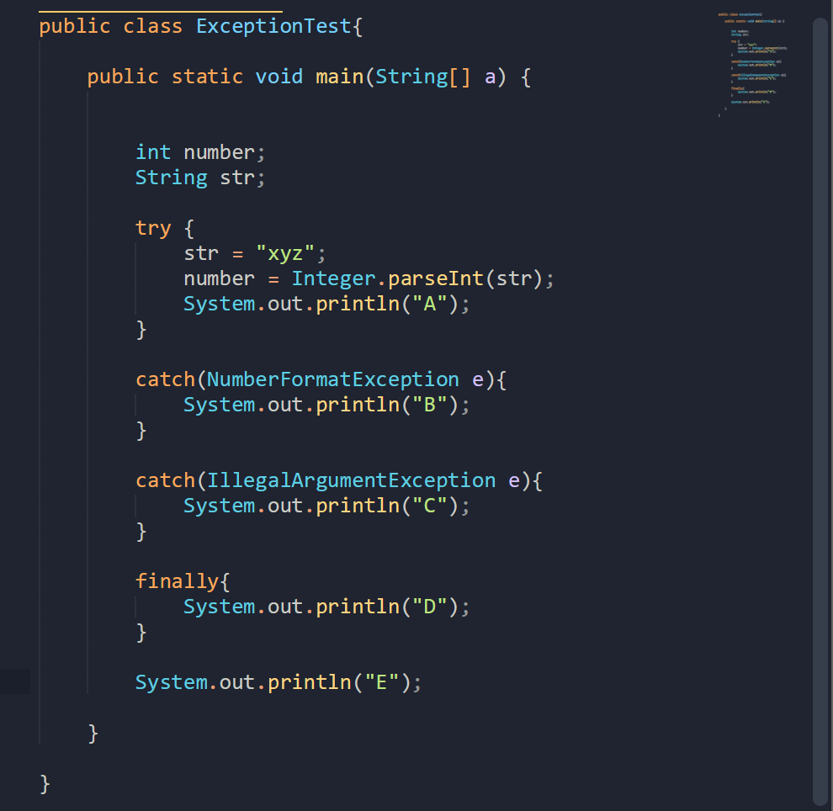

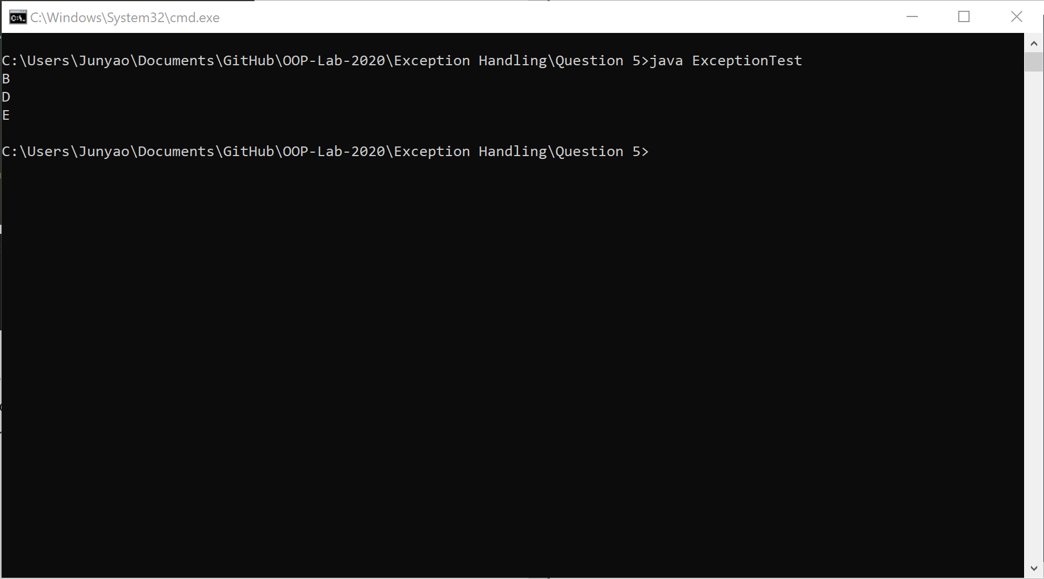

B is printed as the thrown exception is instance of NumberFormatException. Then D is printed as the finally block is always executed. The last output, E is printed, as the program return to the main function.

Q6

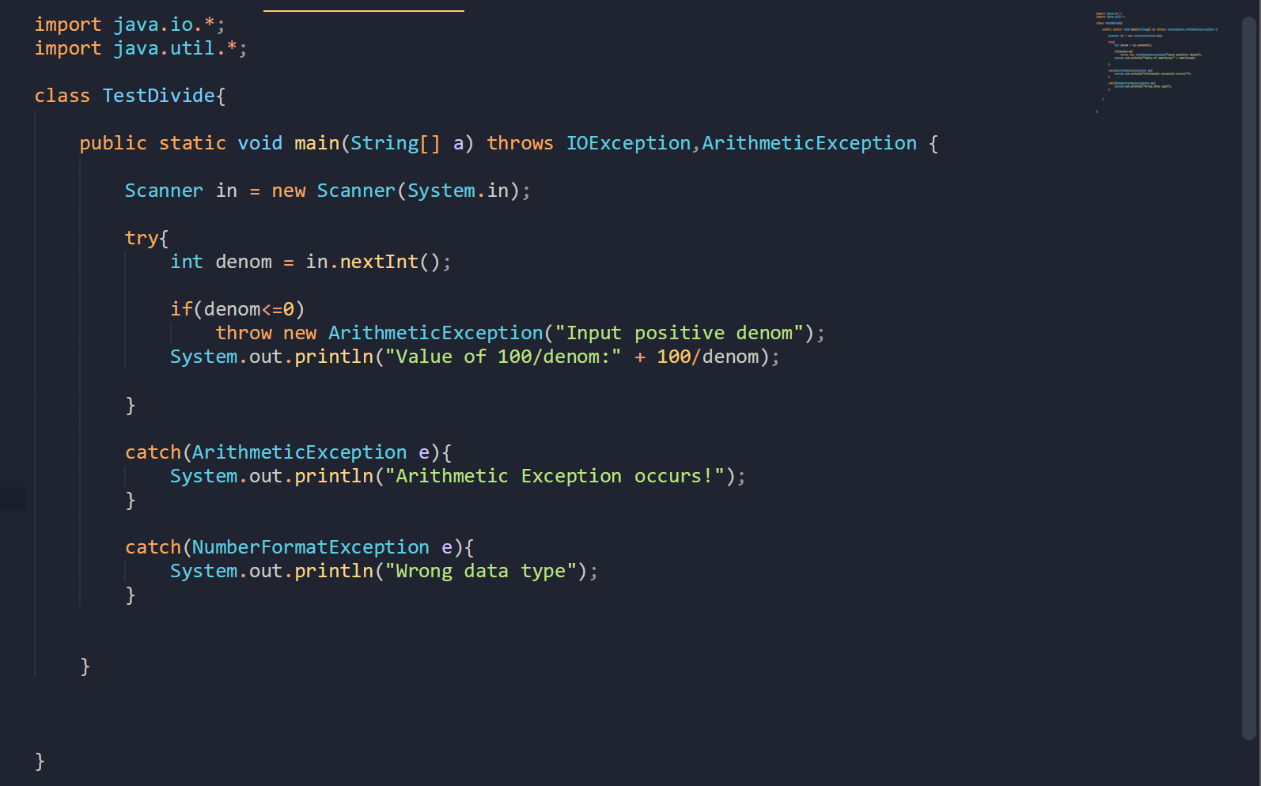

This program declared to be capable of throwing exception that is instance of IOException and ArithmeticException. The program accepts input from the user through the console input. In the try block, the program attempts to use the inputted number as a denominator to divide 100 with it. The program will catch exception thrown by the program, and display corresponding message such that:  
“ArithmeticException occurs!” Will be displayed if ArithmeticException occurs, and “Wrong data type” will be displayed if NumberFormatException occurred.

Page 286 Exercise 4 – Throw Exception

Q1

Because the exception has already been caught at the scope in which the rethrow expression occurs, it is rethrown out to the next enclosing try block. Therefore, it cannot be handled by catch blocks at the scope in which the rethrow expression occurred. Any catch blocks for the enclosing try block have an opportunity to catch the exception.

Q2  
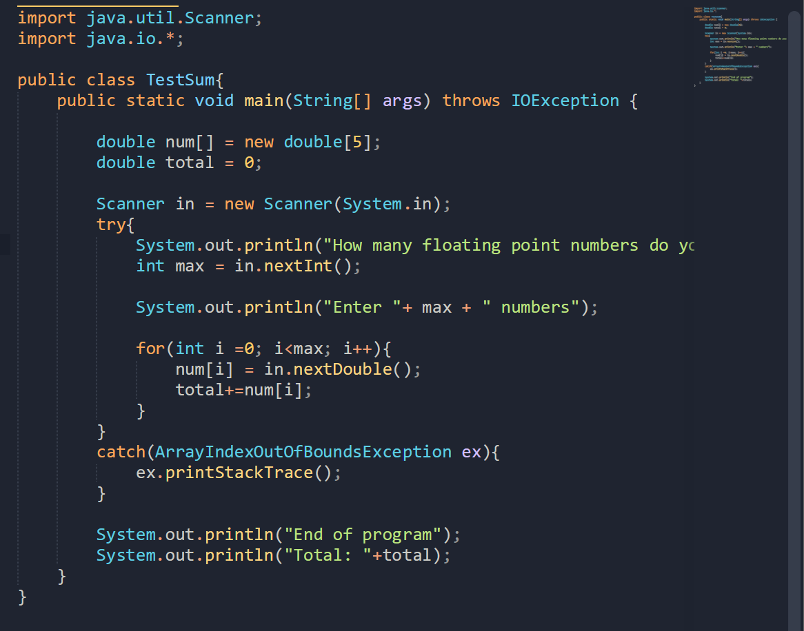  
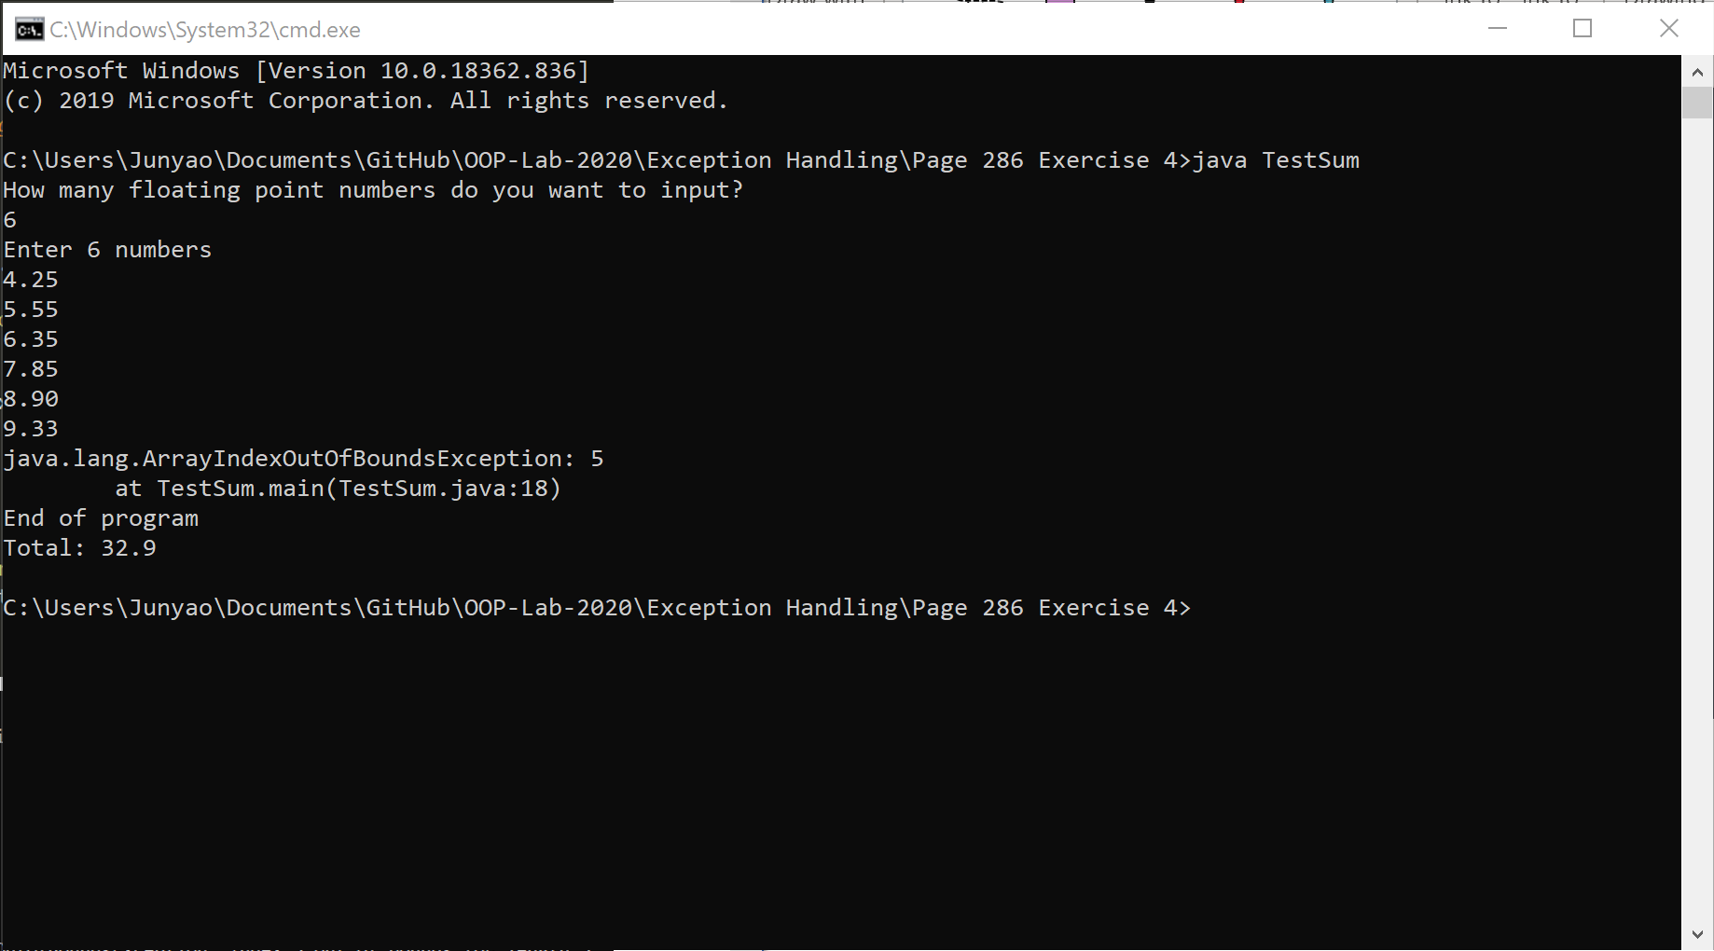  
The exception, ArrayIndexOutofBoundsException is self explanatory: the declared array num[] is an array of double data, which only have a length of 5. The attempt to input 6 number failed as it has exceed the limit of the array.

Page 287 Exercise 5 – Create Own Exception

Q1  
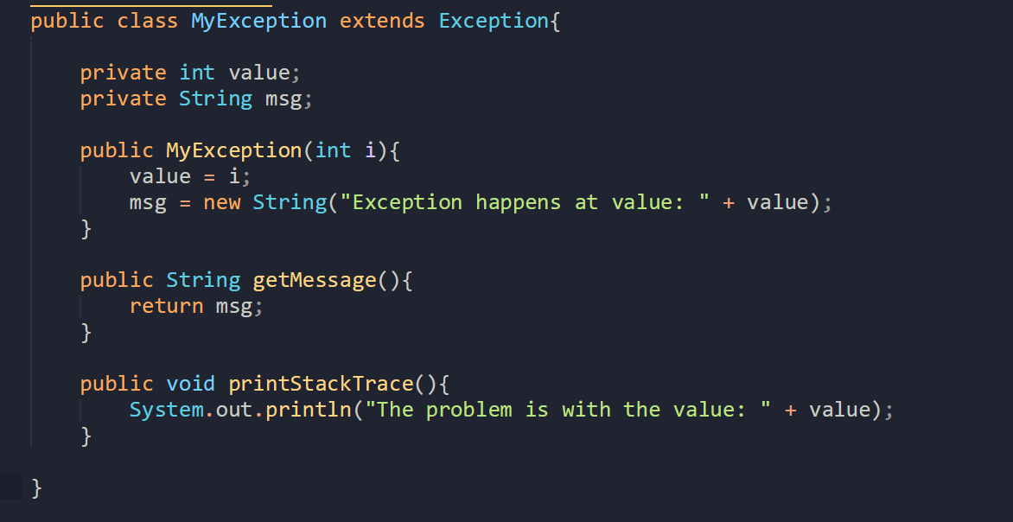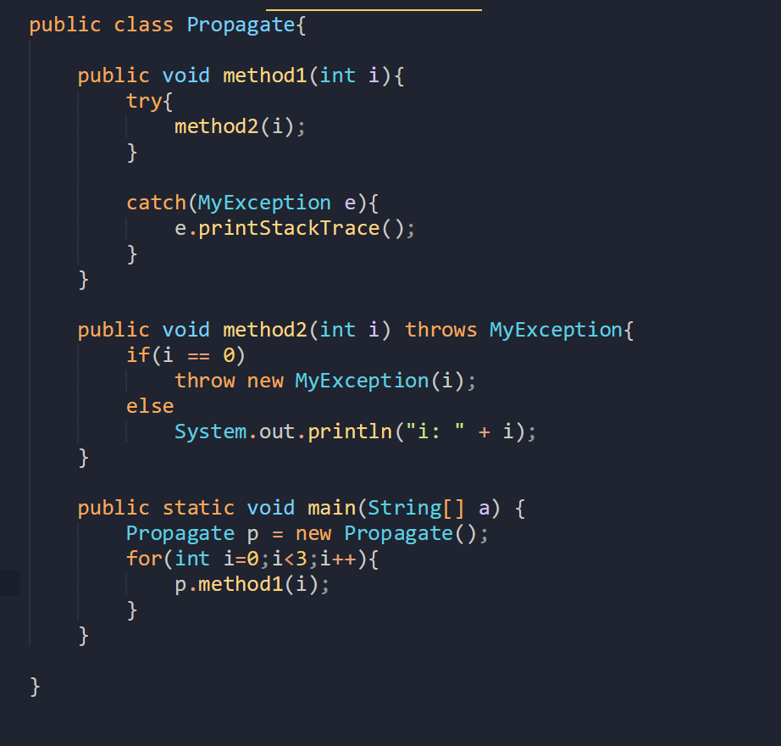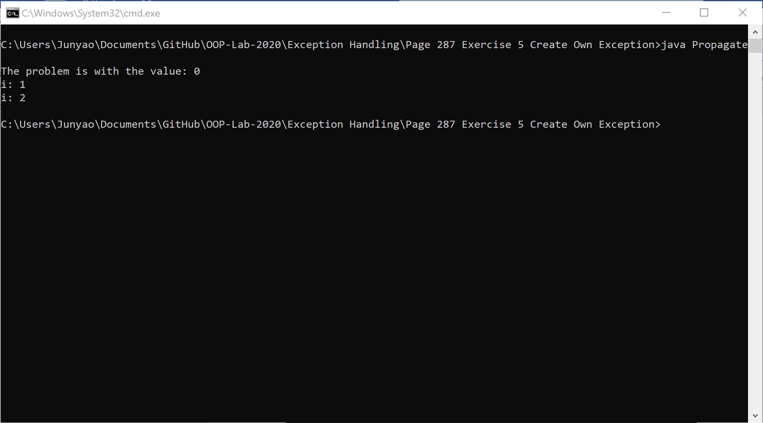

In the main program, a loop is presented, and method1 is called three times using parameter with value 0,1,2. While executing Method1, the try-block in method1 calls method2, and pass the same argument it receives. Method2 will only throw exception if the value equals to zero. Hence, the first value, 0, triggers method2 to throw exception back to method1 to catch it, subsequently printing the trace stack of the exception. The following numbers did not trigger exception in method2, hence the else block in method to executed, where the output “i: [argument]” is printed.

Q2

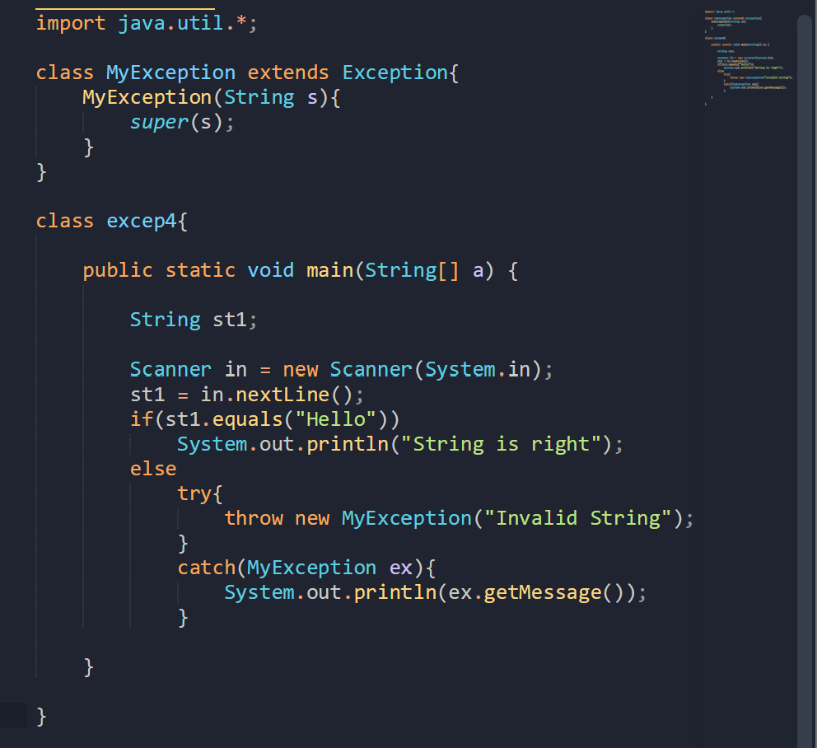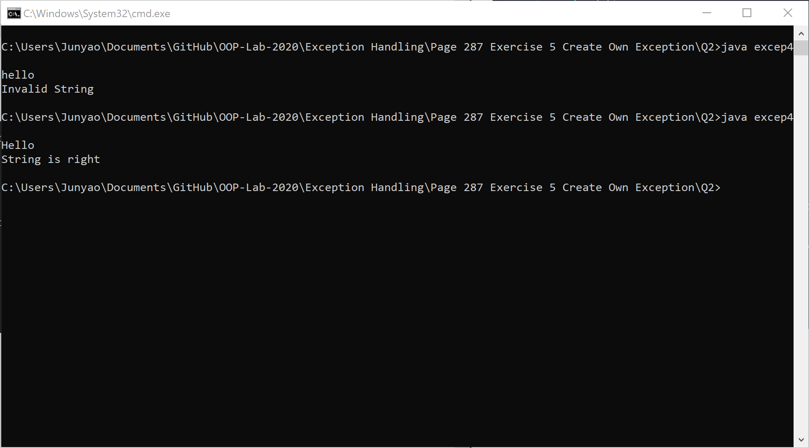  
Errors:

1. Class Name should start with capital letters (i.e.: MyException instead of myexception)
2. String comparison should be using StringObject.equals() method instead of using comparator “==”